## Deep & Shallow Copy

## LAB # 04



**Fall 2020**

**CSE208L Object Oriented Programming Lab**

Submitted by: **Fawad Ali** Registration No. : **19PWCSE1845** Class Section: **C**

“On my honor, as student of University of Engineering and Technology, I have neither given nor received unauthorized assistance on this academic work.”

Student Signature:

Submitted to:

## Engr. Sumayyea Salahuddin

December 26, 2020

Department of Computer Systems Engineering University of Engineering and Technology, Peshawar

# Objectives of the Lab:

* Understand and implement parameterless and parameterized constructor in a class.
* Write a class C++ with overloaded constructors.
* Write a test program to use default copy constructor C++.
* Understand the difference between a Shallow Copy and a Deep Copy.
* Understand the concept of dynamic memory allocation.
* Implement deep and shallow copy in a class C++.Use and test deep and shallow copy in a class.
* Understand and implement destructor in a class C++.

**Activity # 01**

**Title:**

Create a class called employee. This class maintains information about name (char*),department (char*), salary (double), and period of service in years (double).

# Problem analysis:

1. Provide a parameterless constructor to initialize the data members to some fixed values.
2. Provide a 4-argument parameterized constructor to initialize the members to values sent

from calling function.

1. (You have to make dynamic allocation for both name and department data

members in constructor.)

1. Provide a copy-constructor that performs the deep copy of the data members.
2. Provide an input function that takes all the values from user during run-time.
3. Provide a show function that shows all the information about a specific employee to user.
4. Provide a destructor to free the memory allocated to name and department in constructor.

# Algorithm:

* First make class Employee.
* Declare pointer name, department and double for salary, servies of year as private member.
* Define no argument constructor to set value of zero and empty.
* Define overloaded constructor.
* Define input function for the input values to the user.
* Define show function to display the values.
* In main function, make objects e1,e2,e3 to demonstrate the use of Employee.
* Call each function one after the other and display the display function as show.

**In C++**

**Source code:**

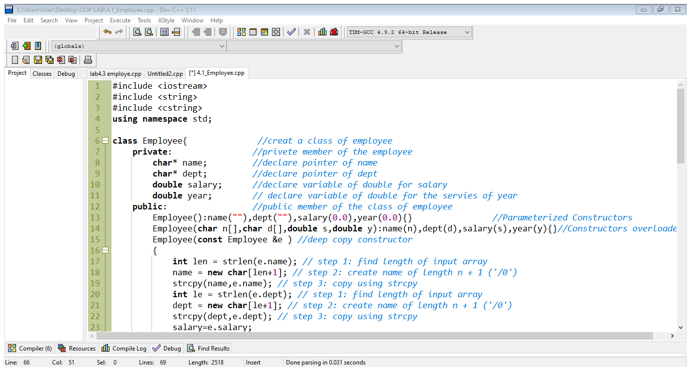

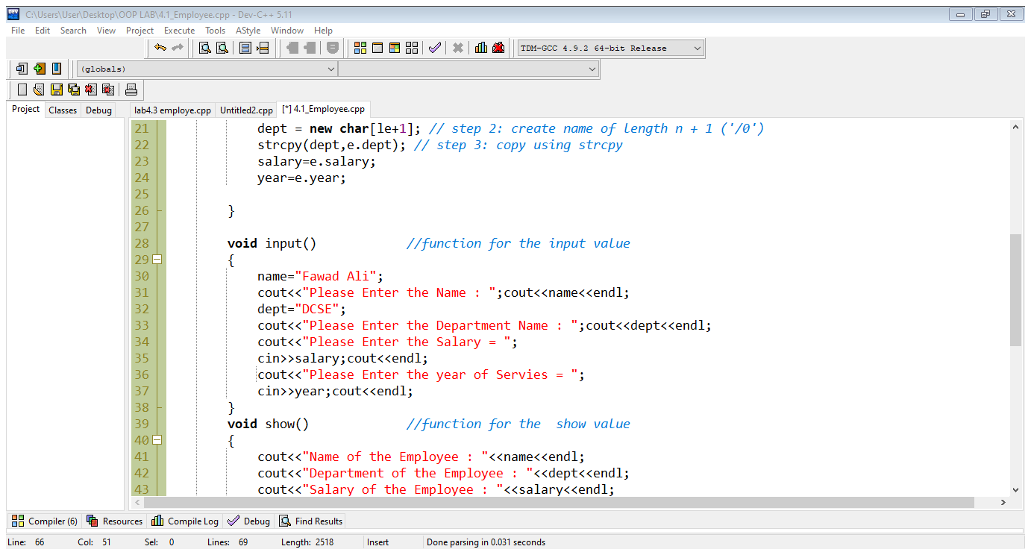

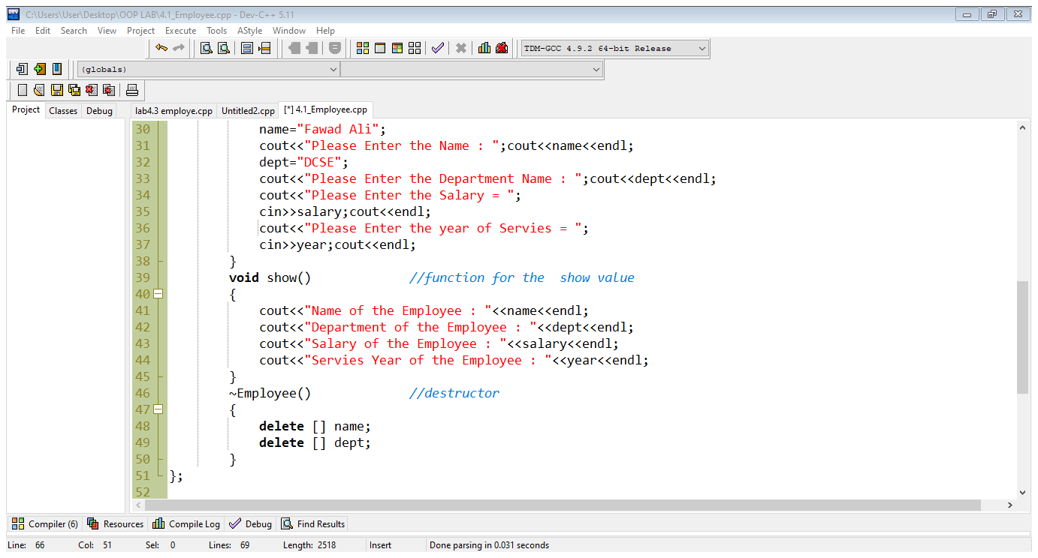

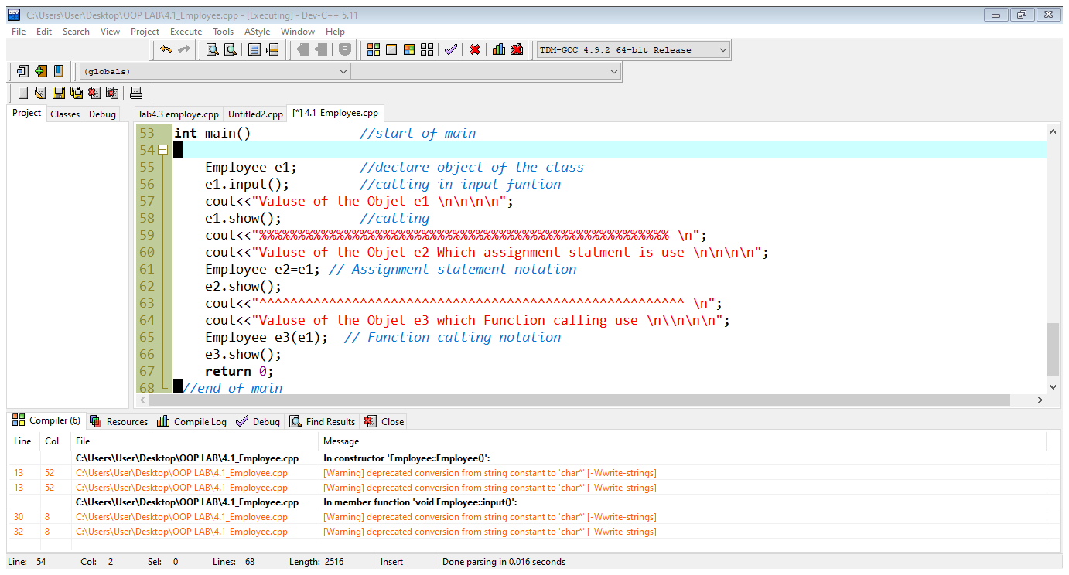

**Output:**

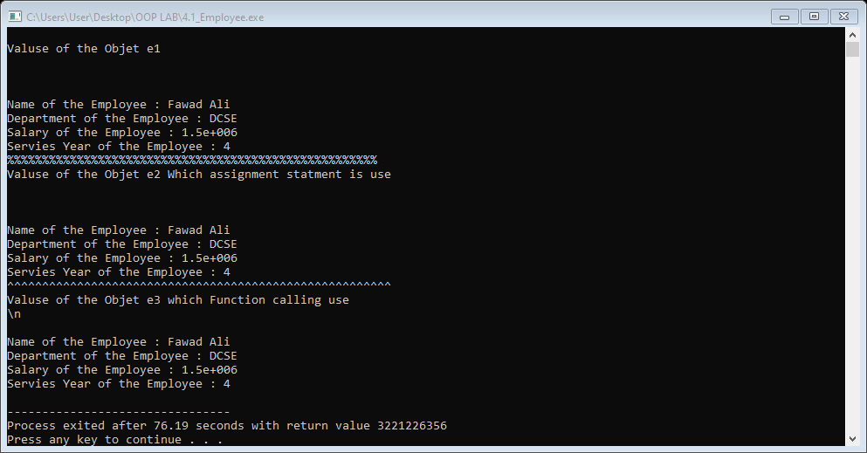

**Conclusion:**

This program helps us in understanding the basic concepts of classes and objects in C++ language. It acts as a base for us and helps us in preparing ourselves for the higher level of programming. We get to know about the constructor and overloaded constructor. We understanding the shallow and deep copy and the destructor.